RC tutorial 100 – Signaling interlocking train routes, 3D and Table example

=============================================================

Revised 2019-09-14

* Assumed skills: basic RailCOMPLETE knowledge
* Time to spend here: Intermediate: 4 hours
* This tutorial's goal is to show how to produce interlocking tables, 3D and Signal tables.
* We are fully aware that it takes training to understand how to use RailCOMPLETE. But please try to work your way through this interlocking / 3D / table example
* This example was prepared using software release 2018.22.1282 with Norwegian DNA version “2019.1 gamma” (still under development).

To make interlocking tables (i.e. just the train route lists at present), do the following:

1. First build your track network, imported from LandXML or other. We have prepared an example using one of the standard tutorials LandXML files, “Example station XYZZY” in a folder on your computer named something like “C:\Users\YOURUSERNAME\AppData\Roaming\Autodesk\ApplicationPlugins\RC.bundle\Help\Tutorials”. You may also locate the LandXML example files by selecting Railcomplete/Tutorials from the ribbon or run RC-ShowTutorials (it opens the Windows file browser at the default tutorials location). Import that file using RC-ImportAlignmentsFromLandXml.
2. Assign reference track definitions to each track (see other tutorials), using the Alignment Manager.
3. Use RC-AssistCreateTrackConnectionObjects to auto-insert all switches and crossings. Clean up manually by changing the Variant to the correct 1:9, 1:12 etc type, if it didn’t come out right in the first place.
4. Assign numbers to all switches’ ‘code’ property (use the RC-ManageProperties tool and just write numbers in the code property for each of them in turn)
5. Insert all isolation joints, RcType == «KO-SKJ Isolert skjøt»
6. Then insert the “SA-SPF Sporfelt” to give names / numbers to each track circuit section. Use the RC-ShowRelationlines tool from the Ribbon to turn on the “Section” highlighting tool.
7. Use the Object Manager’s to assign a sequence of numbers to the track circuit sections (I usually auto-number the sections using their ‘Seq’ (Sequence number) property and the Object Manager’s AutoFill Series function, and afterwards assign for instance the formula “800+Seq” to each section’s ‘code’ property)
8. Then insert your “Class B” signals (i.e. optical signals, not the ERTMS system).  You must use the Norwegian signal types - “Hovedsignal” is a main signal, and “Dvergsignal” is a dwarf signal (shunting signal). Main signals may have shunting signals on the same mast. “Forsignal” is a distant signal.
9. Assign numbers / letters of the form ‘12345L’ or ‘X432’ or ‘C’ or ‘246’ to main signals, so you can recognize their names in the interlocking control table you will make (use the ‘code’ property). Shunting signals usually have just a number.
10. Then use the RC-AssistCreateInterlockingTable function. It should work right away, but you can twist and tweak it to make it work better for your purpose.
11. Remember to refresh objects if they need to read other objects which have meanwhile been changed.
12. See the attached example that we prepared for you:

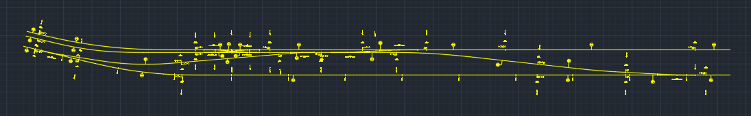

1. The train route tables should like this (see XLS file):

1. To have something nice to look at, you can use start RC-Export3d and remove the “Track axis” and “Alignment axis” checkmarks in the ‘Alignment’ tab (because these choices will suppress expressing the alignments (tracks) using 3D object models). Make sure that the 3D Model Name property has been set to one of the standard sleeper-and-rail models that you can find in the bundled 3D\STD library for 3D object models, for instance NO-BN-3D-KO-SVI-SLEEPER-AND-RAILS. Export to destination = file or to a layer in your drawing.
2. Once everything is set up concerning 3D export, you can turn on 3D preview  and just select objects – they “pop up” in 3D once they are selected.
3. This is what your model should look like in 3D:

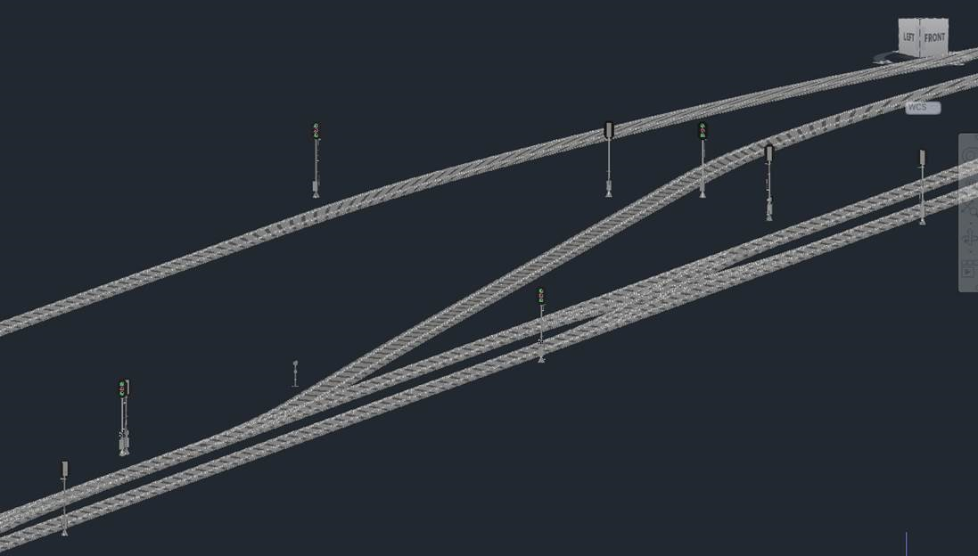

1. From here on, you may experiment yourself putting in boards, ID-boards that you attach to signals etc.
2. And try to produce a table – Here is a standardized “Signaltabell Enkel”:

1. Have fun!

Please check our website www.railcomplete.com for updates.

Corrections and suggestions are welcome to support@railcomplete.no.

Thank you for using RC Tutorials!